TICKET RAISE IN SHIPWAY (AMAZON, DELHIVERY, EKART WITH SHIPWAY AGGRGATOR)
STEP – 1:
Go to https://app.shipway.com/merchant.php?dispatch=auth.login_form&return_url=merchant.php
Username - shivam@theaffordableorganicstore.com, Password - Affordable@123
STEP – 2:
**First check whether particular order is being transported by shipway or not. Go to search, type AWB number. If no match found, then shipway is not the courier partner for that order, so ticket raise is not possible**
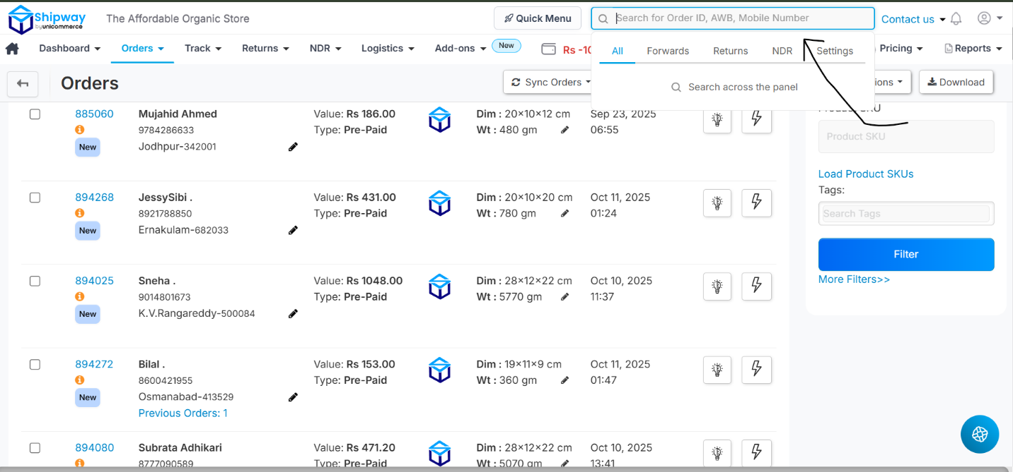

If search result matches, click contact us. Press Click here.
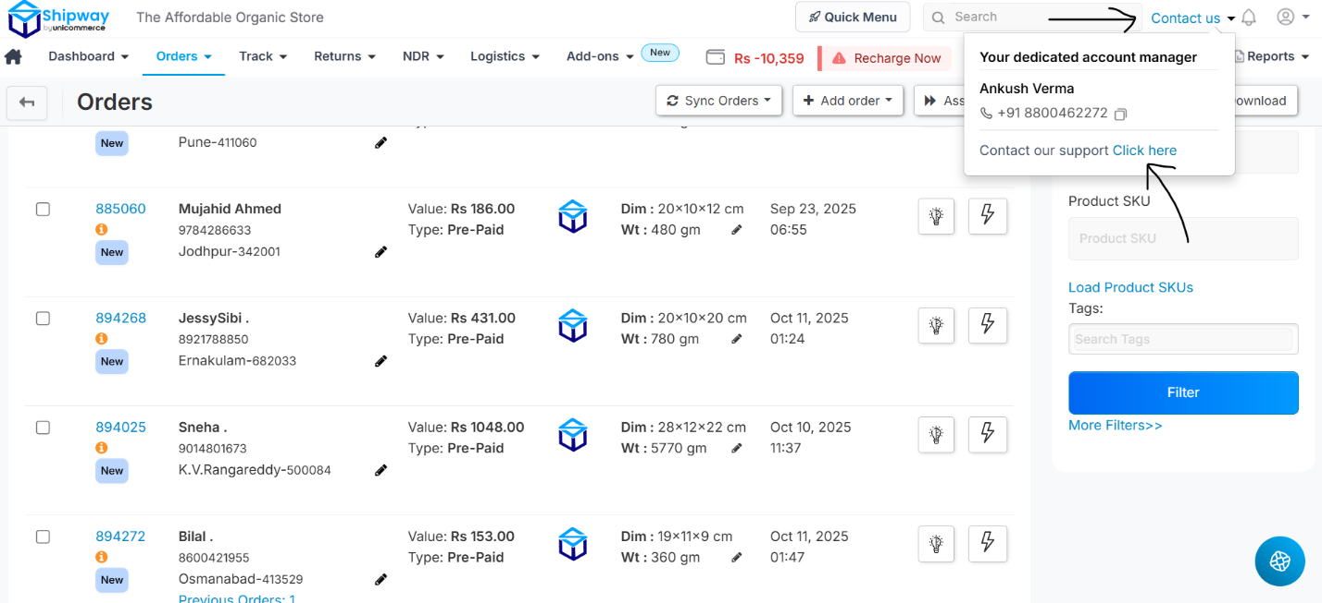
STEP – 3:
Select other queries and then select raise a ticket.
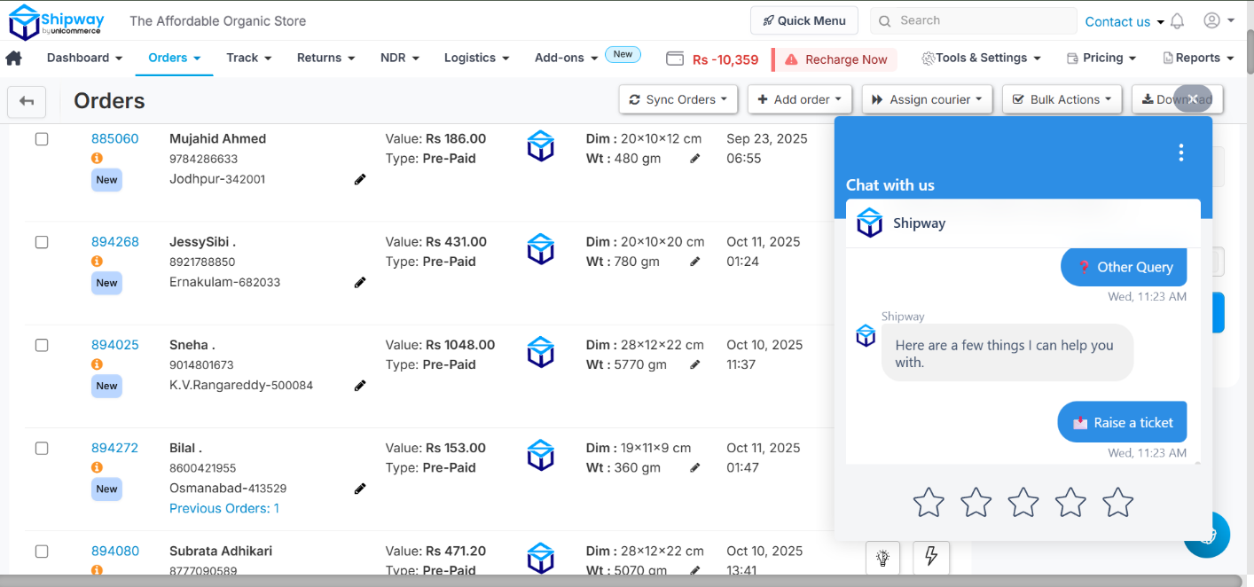
STEP – 4:
Click where the arrow is pointed.
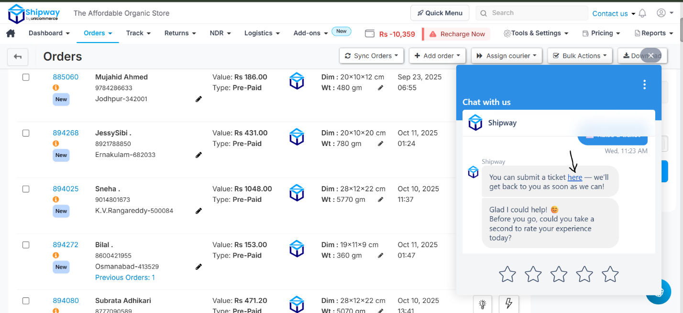

STEP – 5:
Select submit a ticket.
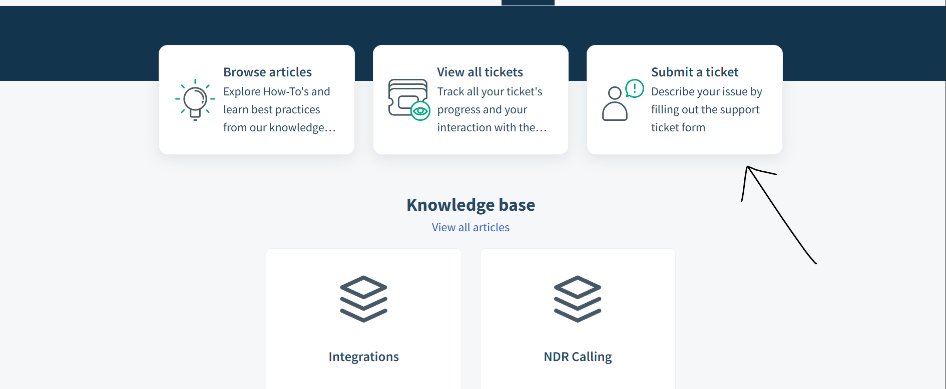
STEP – 6:
Select create ticket here.
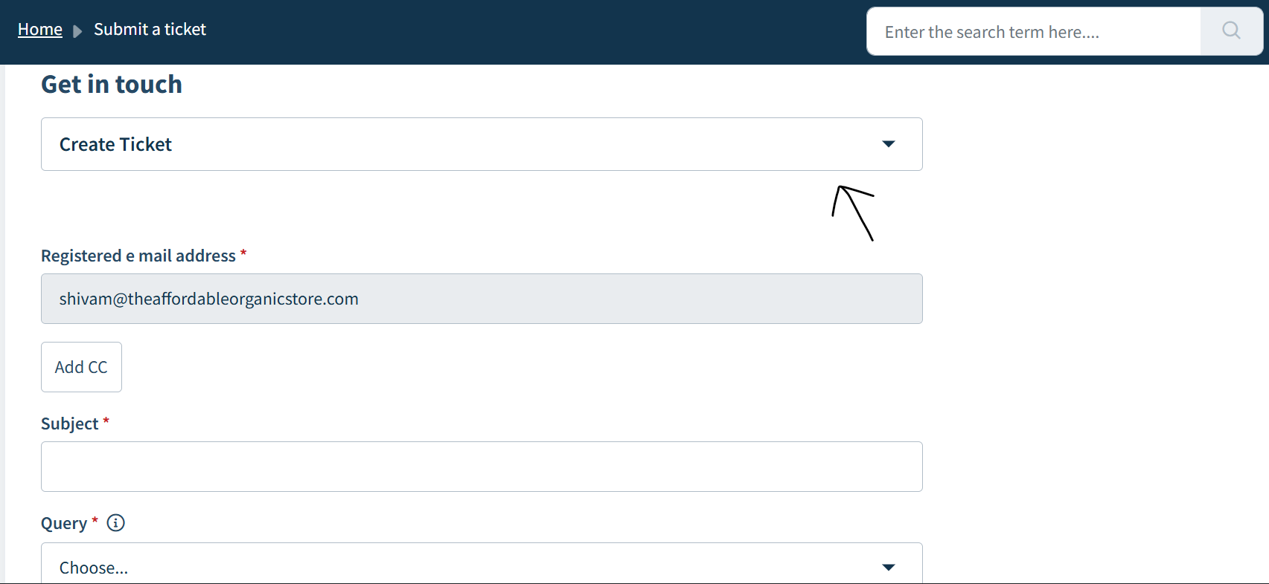

STEP – 7:
Fill up all the necessary forms. In the query all the options are there – POD, RTO, NDR etc.
STEP – 8:
Select Service Type as Shipway Logistics.
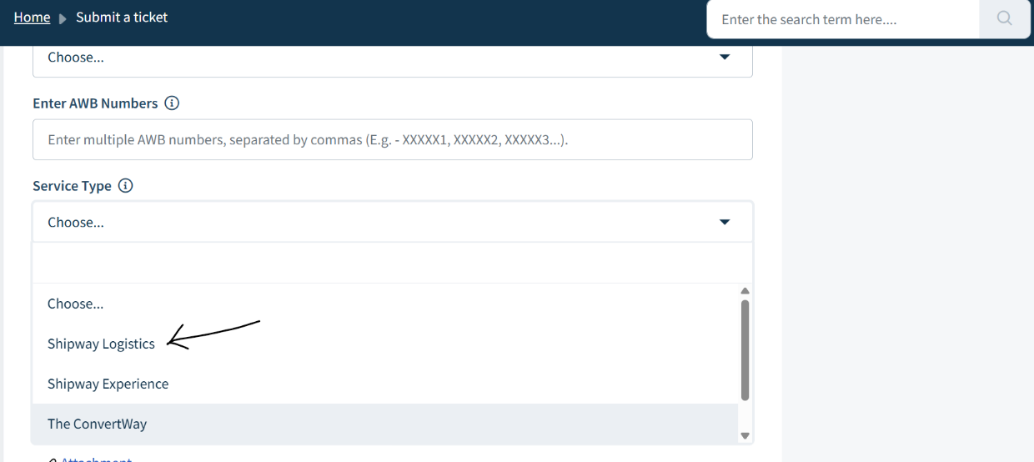
STEP – 9:
In description, write in the mentioned format –
AWB no. _, kindly initiate reattempt asap or kindly provide us the POD of this order.
Screenshot of the tracking details can also be attached if required. Click submit if everything is done.
